2027年布爾諾市復活節盃籃球賽
報名概要

比賽日期：2027年3月25日至28日
年齡組別：U12-U19（男子組與女子組）
參賽對象：
• 籃球俱樂部與青訓營
• 區域代表隊與訓練營
• 學校代表隊
• 業餘球隊

賽事規則與規格
• 4節，每節8分鐘、球場尺寸：15×28公尺
• 採用 FIBA（國際籃總）規則
• 詳細細節請參見官網：https://www.futurestars.cz/en/

報名費用
• 每隊 250 歐元。包含：賽事參與（至少5場比賽）、每場比賽賽事用水、獎品。

住宿方案資訊
A+高級飯店
4天3夜
• 含早餐：270歐元/人
• 含三餐：295歐元/人
5天4夜
• 含早餐：330歐元/人
• 含三餐：355歐元/人
A一般飯店
4天3夜
• 含早餐：235歐元/人
• 含三餐：260歐元/人
5天4夜
• 含早餐：285歐元/人
• 含三餐：310歐元/人
B學生宿舍
4天3夜
• 含早餐：170歐元/人
• 含三餐：195歐元/人
5天4夜
• 含早餐：210歐元/人
• 含三餐：235歐元/人
C學校教室/體育館
4天3夜
• 含早餐：105歐元/人
• 含三餐：130歐元/人
5天4夜
• 含早餐：125歐元/人
• 含三餐：160歐元/人
備註：需自備睡墊與睡袋；亦得加價30歐元代為安排充氣床墊與毯子。

重要日程
• 2026年11月1日：早鳥優惠截止
• 2027年1月30日：報名截止（或額滿即止）
• 2027年3月25日：報到抵達與首輪小組賽
• 2027年3月25日–28日：比賽日
• 2027年3月28日：決賽
(請注意：首場比賽預計於3月25日星期四即開始進行)

聯絡方式
電話：+420 605 124 207
Email：adam@futurestars.cz
網站：www.futurestars.cz
Instagram：future_stars_cup
Facebook：future stars brno





























4 TH EDITIO N
MARCH 2 5 - 2 8 , 2 0 2 7




Ca te g orie s
W HO CAN
PARTICIPATE
U12 - U19 Boys & g irls

Baske tball clubs and acade m ie s Re gional te am s and acade m ie s School te am s
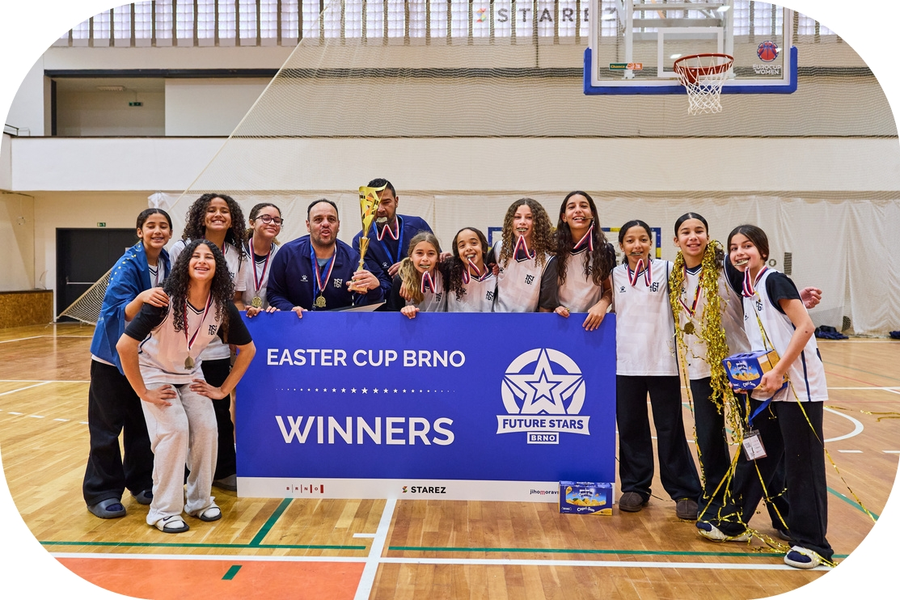


Am ate ur te am s
Ca te g orie s
EASTER CUP
BRNO
25. - 28. 3. 2027
U12 - U19 Boys & girls


END OF
SUMMER CUP
4 x 8 m in FIBA Rule s


15 x 28m
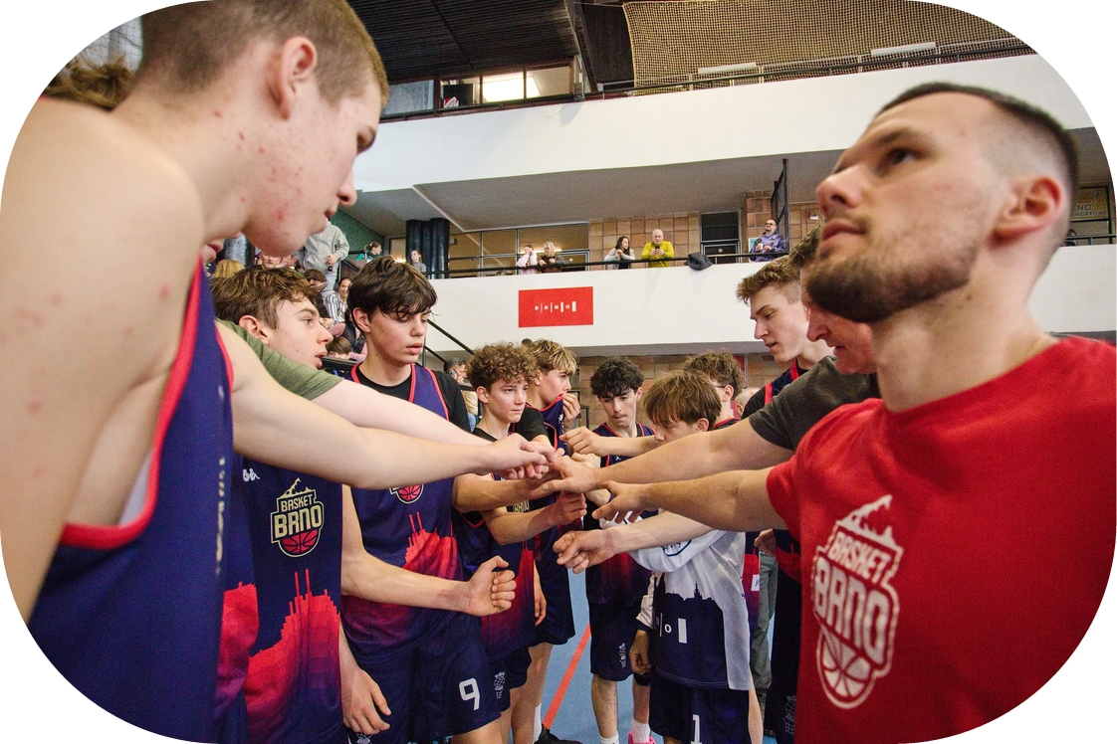
All specified a t the website


Entry fe e 250 € / te am
ACCOMMODATION,
PACKAGES, FEES
Include s participation (m in.5 gam e s), wate r for e ach m atch, and prize s.
Accom m od ation p ackag e - tea m
Include s a snack pack, se le cte d le ve l of accom m odation and m e als,
fre e public transport, and accom panying program (se e we bsite )
Accom m od ation p ackag e - pa rents
Include s an accom m odation and m e als according the choice , fre e public transport, and accom panying program +spe cial program for
pare nts (bre we ry visit / wine tasting)
*a va ila ble only for hotels / premium hotels
Airp ort transfe r
We can organize a private bus pick-up from and back to the airport (prices a ccording the compa nies offers). Close st airport is
in Brno, Wie n, Bratislava, Prague - closer info a t the website
Extra se rvis
Anything e lse we can he lp you? Le t us know and we will pre pare a price
offe r (trip a round Brno, guided city tour, wellness,...)




Price s & op tions
A+) Pre m ium hote ls
ACCOMMODATION
PACKAGES PRICES


Bre akfast only =270 € / p e rson / 3 nig hts / 4 d ays Full b oard =295 € / p e rson / 3 nig hts / 4 d ays
Bre akfast only =330 € / p e rson / 4 nig hts / 5 d ays
Full b oard =355 € / p e rson / 4 nig hts / 5 d ays
- Hote ls
Bre akfast only =235 € / p e rson / 3 nig hts / 4 d ays
Full b oard =260 € / p e rson / 3 nig hts / 4 d ays
Bre akfast only =285 € / p e rson / 4 nig hts / 5 d ays Full b oard =310 € / p e rson / 4 nig hts / 5 d ays
- Dorm itorie s


Bre akfast only =170 € / p e rson / 3 nig hts / 4 d ays Full b oard =195 € / p e rson / 3 nig hts / 4 d ays
Bre akfast only =210 € / p e rson / 4 nig hts / 5 d ays
Full b oard =235 € / p e rson / 4 nig hts / 5 d ays
- School classe s / g ym s


Bre akfast only =105 € / p e rson / 3 nig hts / 4 d ays Full b oard =130 € / p e rson / 3 nig hts / 4 d ays
Bre akfast only =125 € / p e rson / 4 nig hts / 5 d ays
Full b oard =160 € / p e rson / 4 nig hts / 5 d ays *With your own m attre ss and sle e ping bag
**We can arrange an air m attre ss+blanke t for 30 €


Pare nts p ackag e availab le for cate g orie s A+& A
*The price s liste d above are base d on room s with two or m ore be ds.
**Price s for single room s are available upon re que st
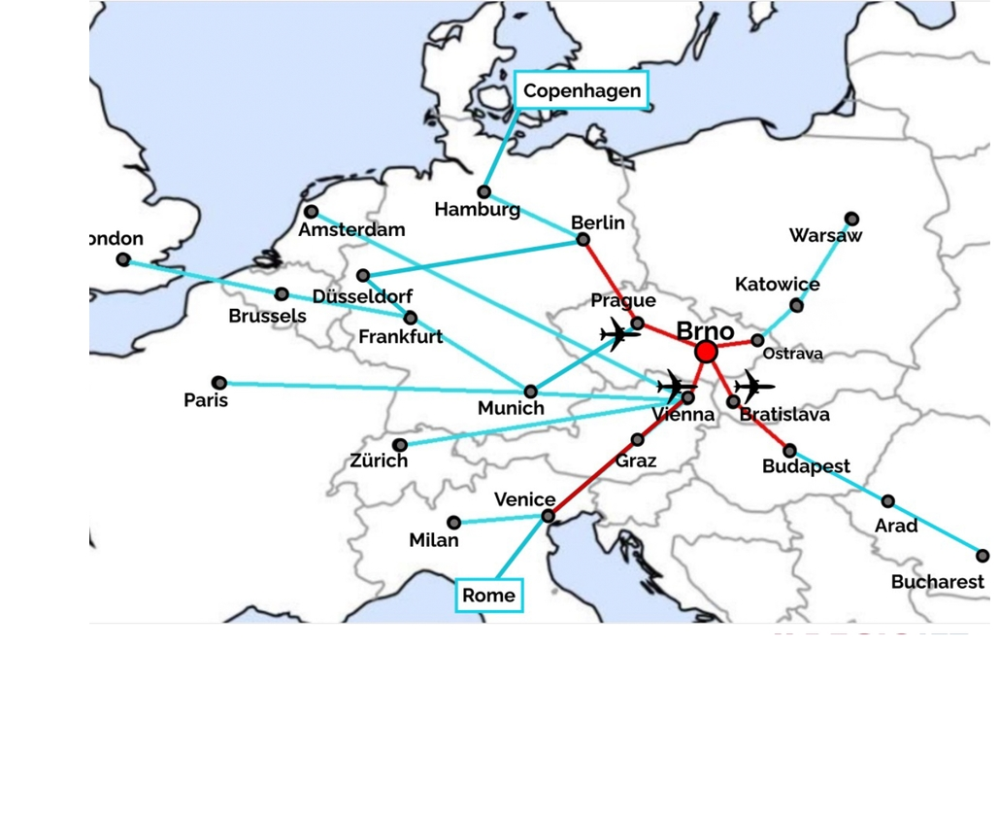
Dire ct flig hts to Brno for 2027 Milano Be rgam o
London Stanse d
Málaga
Frankfurt
How to re ach Brno from othe r d e stinations Private transport
Train
Bus
Flights
Dire ct (m ore above )
Wie n (m ost conve nie nt to ge t to Brno) Bratislava
Prague
Shuttle from airport (we can organize )


EASTER CUP
IMPORTANT
DATES
BRNO 2027
1. 11. 2026
End of Early bird discount
30. 1. 2027
(or untill the group limit fills)
End of re gistrations
25. 3. 2027
Arrivals and first group
m atche s
25.3. - 28. 3. 2027
Gam e days
Finals
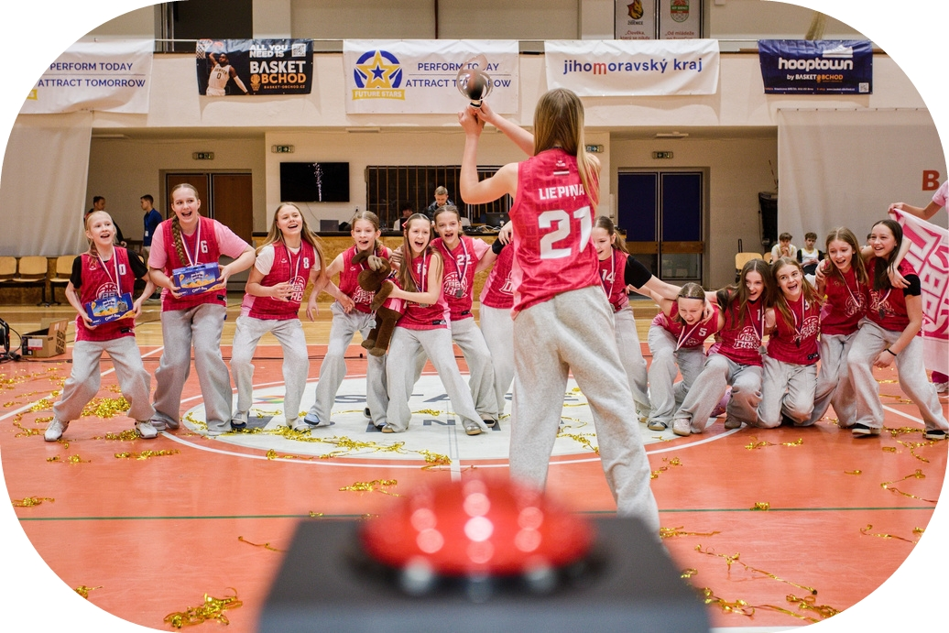
Ple ase count with first m atche s alre ad y on Thursd ay 25th!







+4 2 0 6 0 5 1 2 4 2 0 7
C ONTAC TS





a d a m @fu t u r e s t a r s .c z w w w .fu t u r e s t a r s .c z
fu t u r e _s t a r s _c u p
fu t u r e s t a r s b r n o



Arra n ge a me e t in g, ca ll or a sk a n yt h in g e lse you n e e d t o kn ow

